Home Page

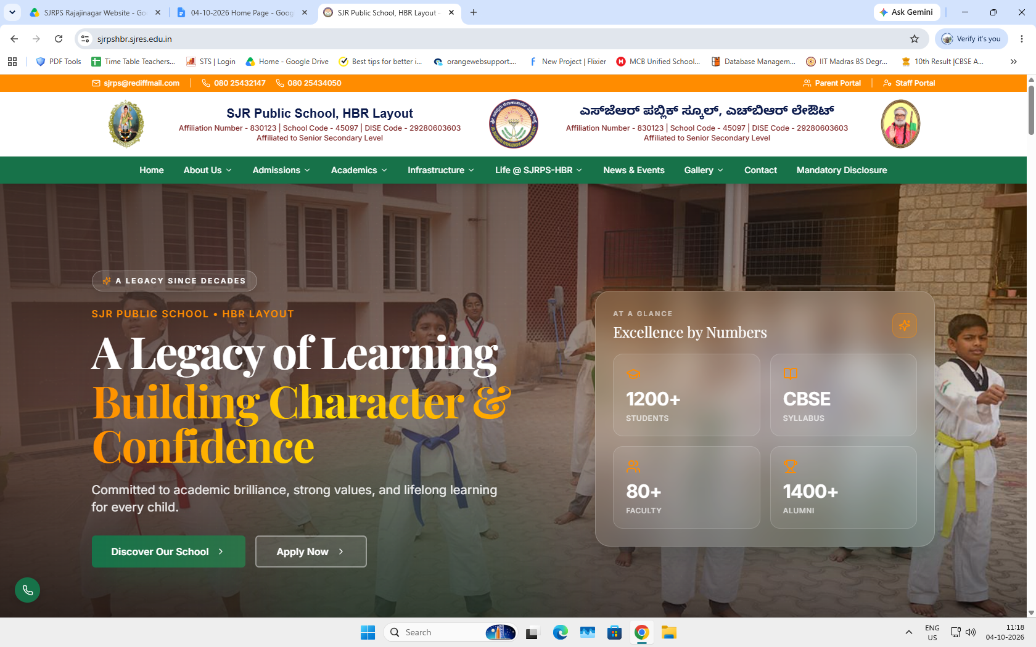

SJR Public School, HBR Layout
Affiliation Number - 830123 | School Code - 45097 | DISE Code - 29280603603
Affiliated to Senior Secondary Level

Changes required
Phone Number - 08023388765, 08023102070
SJR Public School, Rajajinagar
Affiliation Number - 831136 | School Code - 46766 | DISE Code - 29280234402
Affiliated to Secondary Level

Retain all Menus

1000+ students, CBSE Syllabus, 50+ Faculty, 600+ Alumni

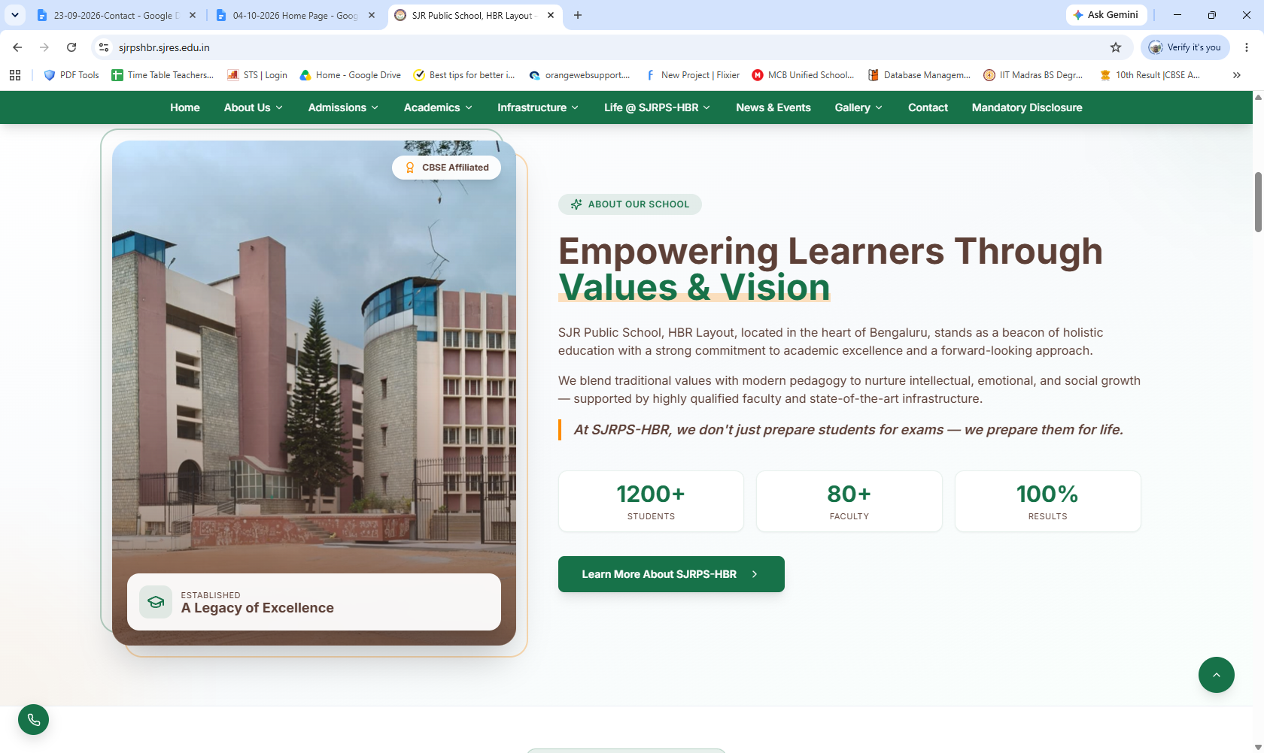
School Building in Picture>School Building folder.
Retain the content with following changes
School Name-SJR Public School, Rajajinagar
1000+ Students, 50+ Faculty, 100% results

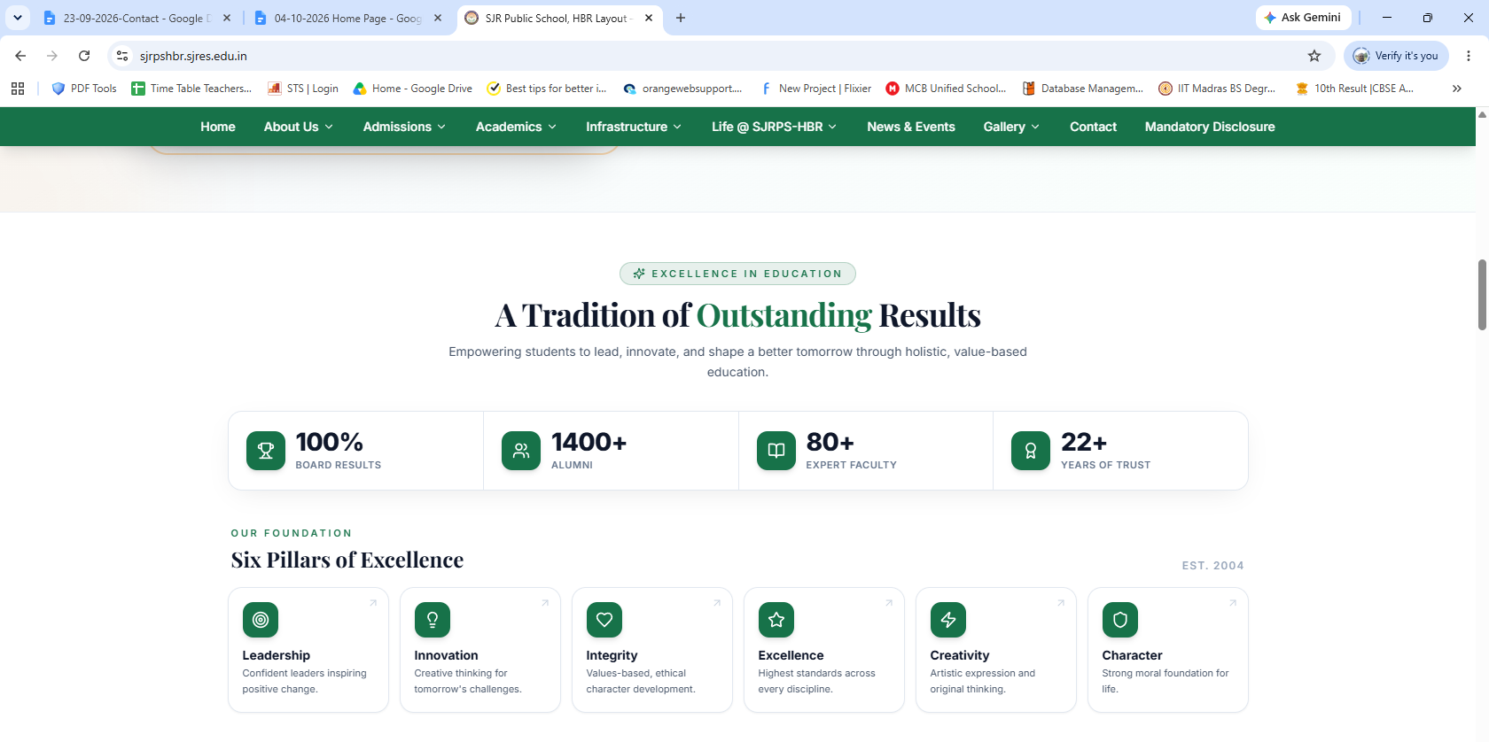

100% Board Results, 600+ Alumni, 50+ Faculty, 600+ Alumni, 45+ Years of Trust

Retain Our Foundation. Estd. 1981

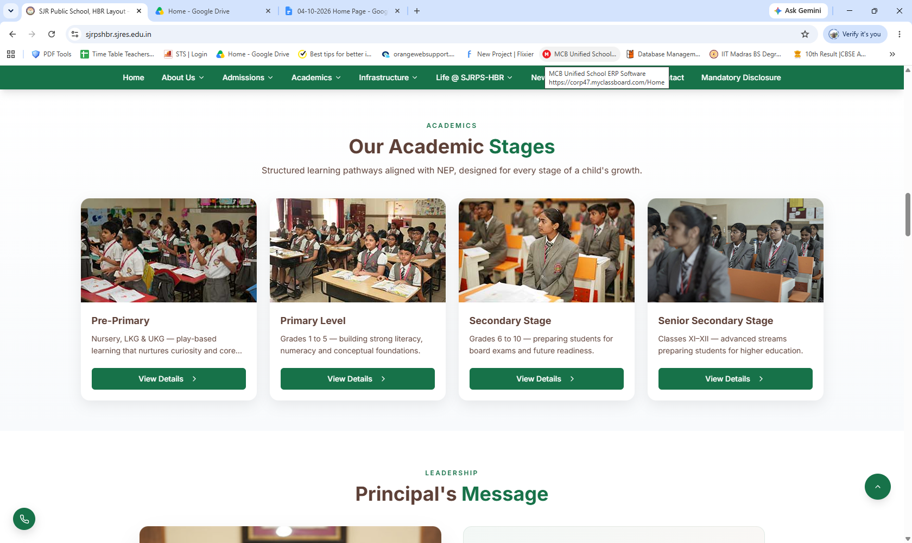
Keep only Pre-Primary, Primary Level and Secondary stage tabs.
Photos are in Photos-Home Page Photos-Primary class and Secondary class photos

Retain the content with school name change

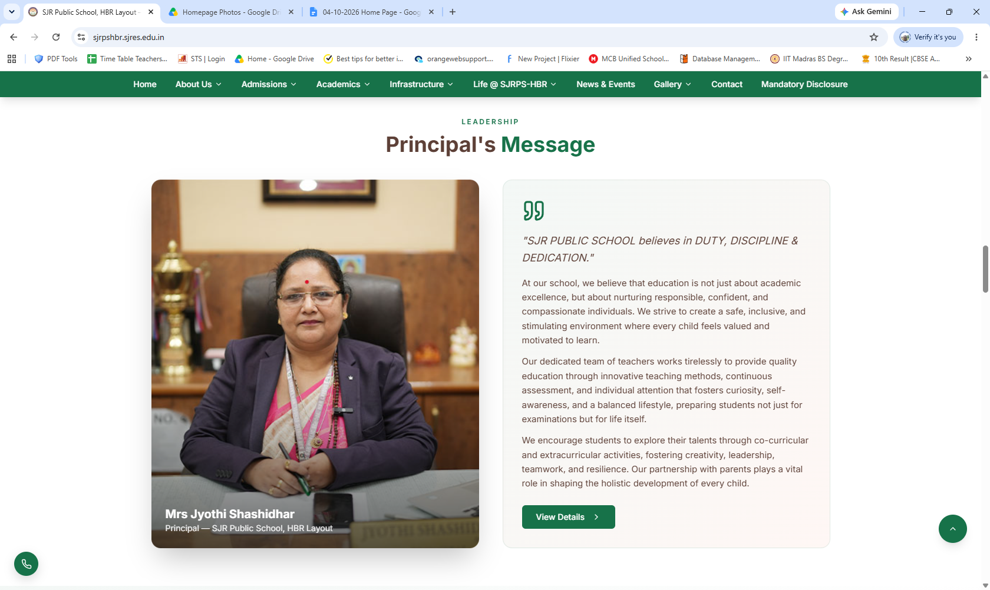

Mrs Poornima N Kagali
Principal- SJR Public School, Rajajinagar

“Education is not merely about preparing a child for examinations; it is about preparing a child for life.”

Vision:
To nurture confident, compassionate and responsible individuals who learn with purpose, live with integrity and grow into capable, resilient and lifelong learners.

Mission:
We at SJR are committed to provide every child with meaningful learning, strong values and emotional well-being in a safe and supportive environment. We identify and nurture each child’s unique potential, develop character and life skills and prepare for a successful, fulfilling and responsible life.

“Every Child Matters, Every Journey Matters, Every Future Matters.”

Infrastructure

World-Class Facilities
Retain the content. Photos are available in the Photos>Infrastructure folder.

Gallery

Moments at SJRPS-HBR

Photos are available in the Photos>Infrastructure folder.

Meet Our Faculty

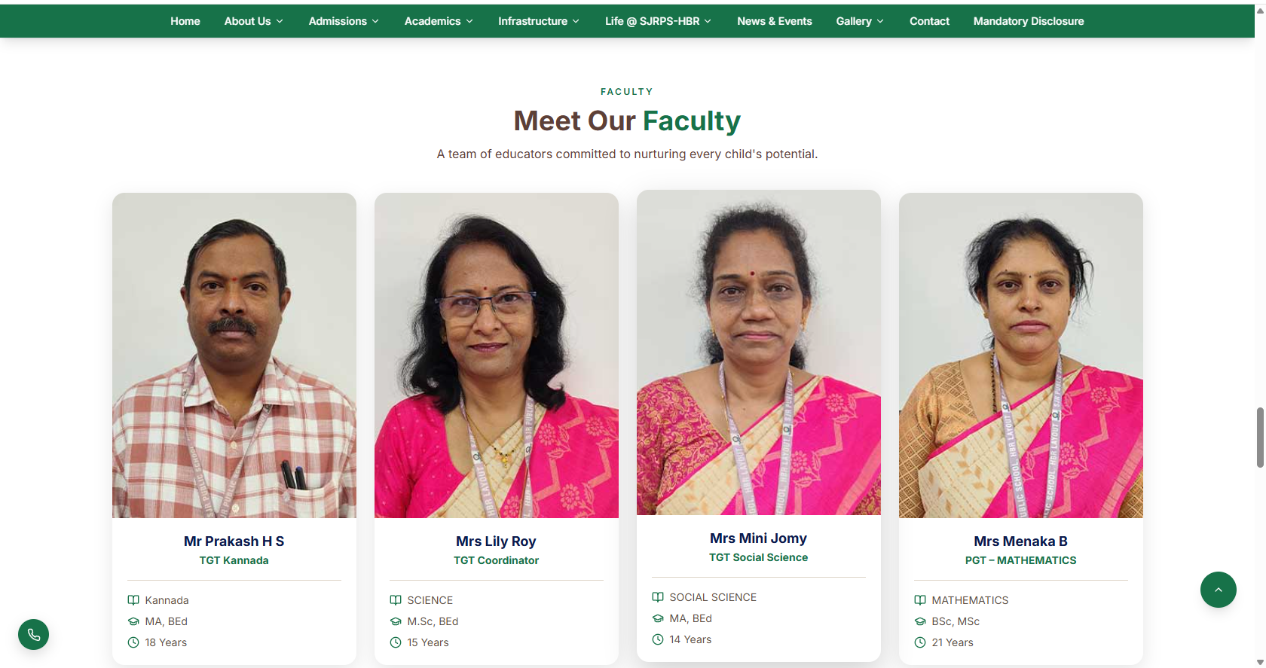
Changes required

Photos, Names, Qualification, Experience years are present in Photos>Staff photo folder with excel sheet.
Stay Updated

News & Upcoming Events

Details are available in the News and Events tab.

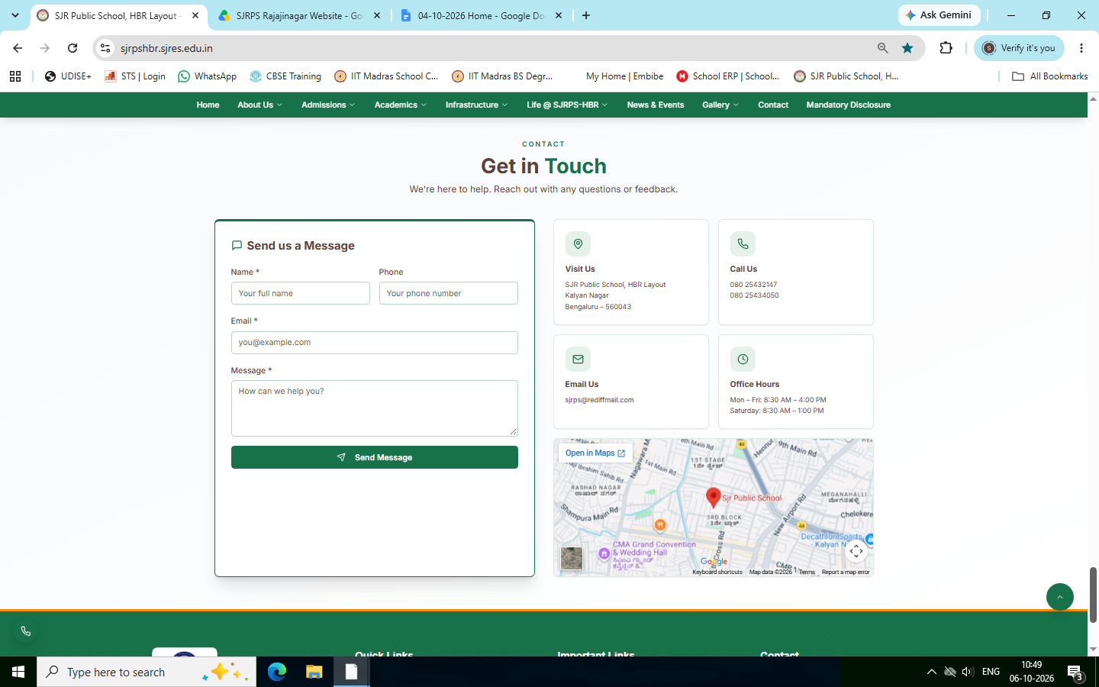
Changes required
Visit Us - SJR Public School, Rajajinagar,
Bengaluru – 560043
Contact Us - 08023388765, 08023102070
Email Us - principalsjrphs@gmail.com

Office Hours
Mon – Fri: 8:30 AM – 4:00 PM
Saturday: 8:30 AM – 1:00 PM

Google Map Location
https://maps.app.goo.gl/p6TK8x1gM61onRTw6

